# images

**LOVELY PROFESSIONAL UNIVERSITY**

A Report on Artificial Intelligence(AI) Project

Done by:

|  |  |  |
| --- | --- | --- |
| Name | Registration No. | Roll No. |
| Disha Arora | 11806276 | B34 |
| Akashdeep Chattopadhyay | 11806436 | B40 |
| Puru Johri | 11806354 | B58 |
| Aviral Jain | 11806368 | B59 |

Github:

<https://github.com/Akashdeep-312>

<https://github.com/AviralJain165>

Section: K18GE

Under the guidance of:

Name: Shabnam

Designation: Asst. Professor

Subject: INT404 (Artificial Intelligence)

Contents Page No

Acknowledgement.…………………………………………………………………3

Overview………………………………………………………………………………..4

Project Description…………..…………………………………………………….4

Working Model Description..………………………………………………….4

Code Description……………………………………………………………………5

Credits……………………………………………………………………………………5

Grant t Chart.…………………………………………………………………………6

Acknowledgement

I would like to thank all the members of my team to help me out in completing the project report on “**Chat-bot for Placement Selection**” and I would also like to thank Ma’am Shabnam for giving us the opportunity to create such a project.

Successfully working on a project means working with the team members with major efforts to bring out some good ideas.

I would like to thank all my friends to give me a clear idea about the project.

Overview

In today’s era we are living in a digital world where there are machines to work for us. Thus a few people suggested that there is a dire need of machines in the field of job recruiting so that there will be much flexibility in the interview. Numerous ideas revealed that a chat-bot can assist the user to get prepared for job interviews. It is the ability of the device that can make the user feel very easy in knowing everything about any job interview. Not only the chat-bot are used for the task of placement selection, but in today’s world, they have a very wide applications.

A chatbot (also known as a talkbot, chatterbot, Bot, IM bot, interactive agent, or Artificial Conversational Entity) is a computer program or an artificial intelligence which conducts a conversation via auditory or textual methods. Chatbots are typically used in dialog systems for various practical purposes including customer service or information acquisition.

Project Description

The project is a **Placement Selection Chat-bot** which performs various activities like how the placements are going to be conducted, the placement phases, who are going to be the recruiters, etc.

Working Model Description

Numerous ideas were there and finally we came out with a suggestion that the chat-bot should be designed by means of simple code, where the chat-bot will greet the user, answer the questions of the user that who are the recruiters, on what criteria will they select students, and much more. Ending the conversation with the chat-bot with a thank-you greet, the user will get to know everything about the placements.

Code Description

The code for any project comes very handy when we understand it. Here the code describe us the description that they will provide us on our response. The code is simple, easy to understand.

The project describes that how the message will be conveyed to the user when the user gives instructions to the chat-bot.

For eg.,

1. ['(.*) placement drives' **(this portion refers to the instruction given by the user)** ,[' you will know it via ums or lpu touch.anything else i can help with?']], **(this portion refers to the answer given by the chat-bot).**
2. **To trigger the conversation :**

chat.converse()

1. **Reflections - To substitute the other in place of some.**

my_dummy_reflections={‘go’:’gone’,’hello’:’hey there’}

**Which means the user can utter ‘gone’ in place of ‘go’ or ‘hello’ in place of ‘hey there’**

1. chat=Chat(pairs,my_dummy_reflections)

**Passing the values to the functions.**

Credits

Credits to all the members of the team on working on the project and helping to make the report.

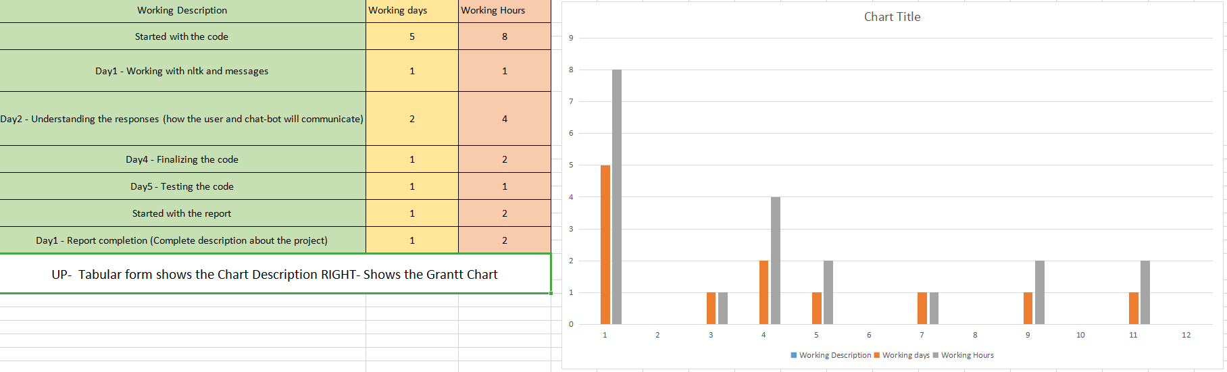Grant t Chart